[Refresh] YEAR END 2023: DEBT

Concept framework
# | Title | Topics | Overview | Visual story | Pub date
3 | Debt and inflation | The what, how and why of debt at this moment. The dangers of increased debt right now. How to protect yourself. | Debt is on the rise along with everything else. Central banks are tightening up as they try to curb inflation, and how that will play out through 2023 is still fuzzy.  That doesn’t change your bills though – what can you do day to day to move forward during this frenzied economic moment? | Maya rides her motorcycle to the cliff and starts rock climbing. | 12.14

Screen 1: Cover Template
Layouts |  | Content | Designs
[Label – 30]  [Title – 55]  [Description – 130]  [CTA – ]  [Short – 55] |  | [Label – / 30]  YEAR END 2023  [Title – / 55]  Tackling debt when rates are up?  [Description – 122 / 130]  Personal debt is overwhelming households this year. How did we get to this point? And what can you do to find your balance and stay ahead for the year to come?  [CTA – ]  Start reading  [Short – 55] | 
Screen 2: Context Template
Layout |  | Content | Designs
[Title – 45]  [Paragraph 1 – 147]  [Paragraph 2 – 147]  [Tip – 190]  While that’s a good sign, it’s still 6 points higher than this time 2 years ago.  In the lead up to December, inflation eased up from 7.7% to 7.1%.  To keep up with the price surge, many have borrowed more often and at higher amounts. Some still wonder what kind of recession may be approaching.  Why? |  | [Title – / 45]  Inflation finally cooling down?  Are you feeling the heat?  [Paragraph 1 – / 147]  Since last year, inflation has been steadily cooling down to 3.1% from last year’s 7.7%. But debt is still creeping up. Why?  [Paragraph 2 – / 147]  With mortgage prices continuing to spike, student loan payments coming off pause, and credit debt rising, many are still waiting for relief.  [Tip – / 190] What’s the Fed been doing?  This year, they’ve steadily raised rates to fight inflation. Heading into next year, interest rates will likely stay the same until the Fed hits their goal of 2% inflation. | 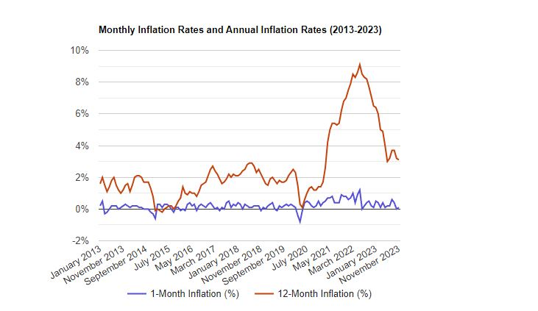
Screen 3: Context Template
Layout |  | Content | Designs
[Title – 45]  [Paragraph 1 – 147]  [Paragraph 2 – 147]  For the majority of family’s, mortgages in this year’s hyper-competitive housing market continue to take up a larger chunk of their total debt.  And on top of it all, back in October student loan payments resumed and interest started accruing again. Keeping up with that pace is no easy task. |  | [Title – / 45]  Chart: Credit usage change year-to-year  Steepest spike in credit card use since 2002  [Paragraph 1 – / 147]  Borrowing may seem like a fix, but adding debts while interest rates are up to fight inflation is risky exposure. They quickly swell and are hard to pay.  Borrowing may seem like a fix, but it’s risky exposure when interest rates are up to fight inflation. New debts quickly swell and are hard to pay.  [Paragraph 2 – / 147]  Mortgages top the charts this year, but credit debt continued to rise, surpassing $1 trillion. Keeping up with that pace is no easy task. | 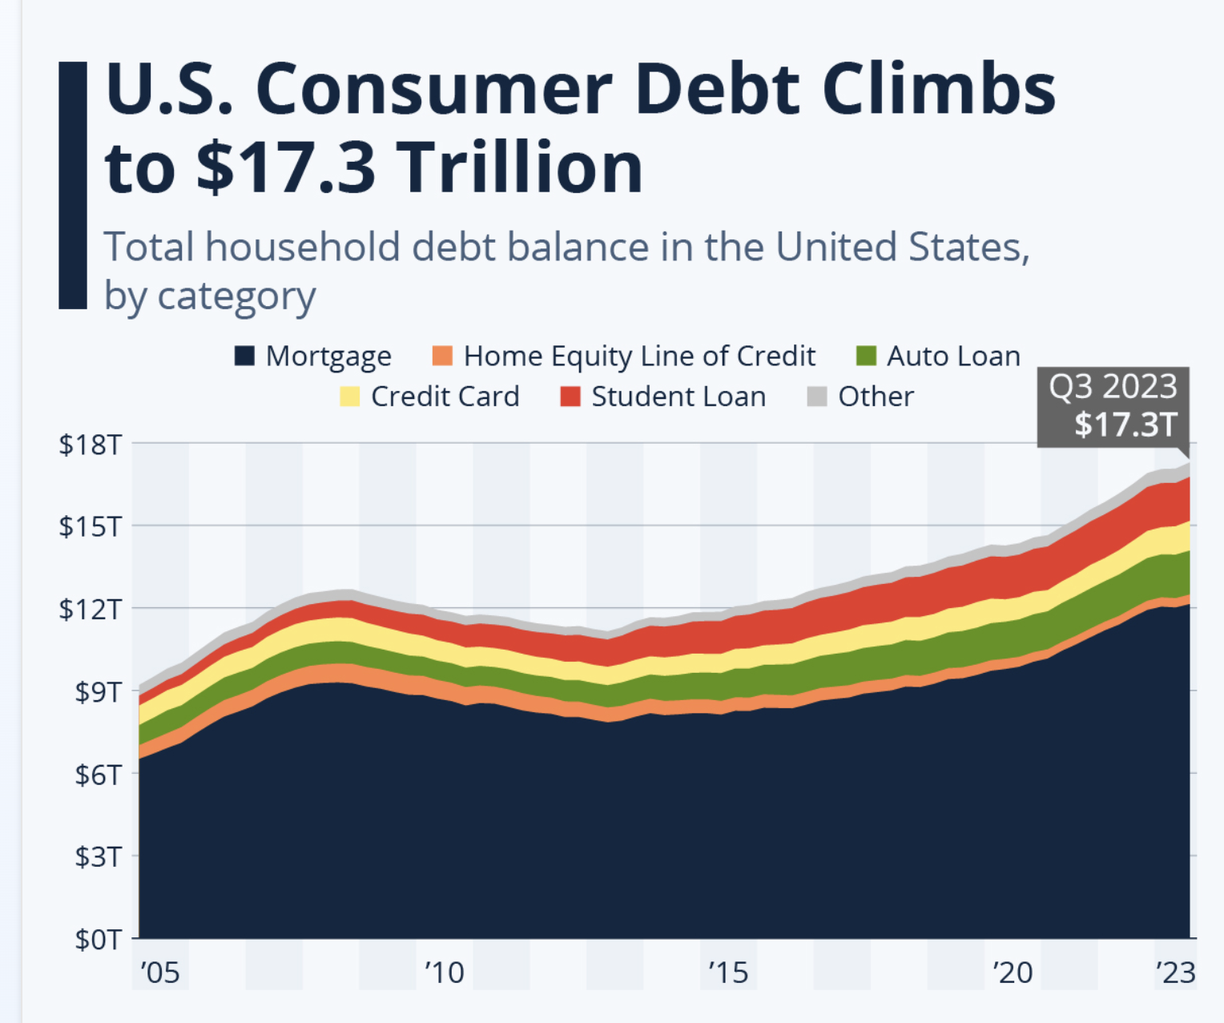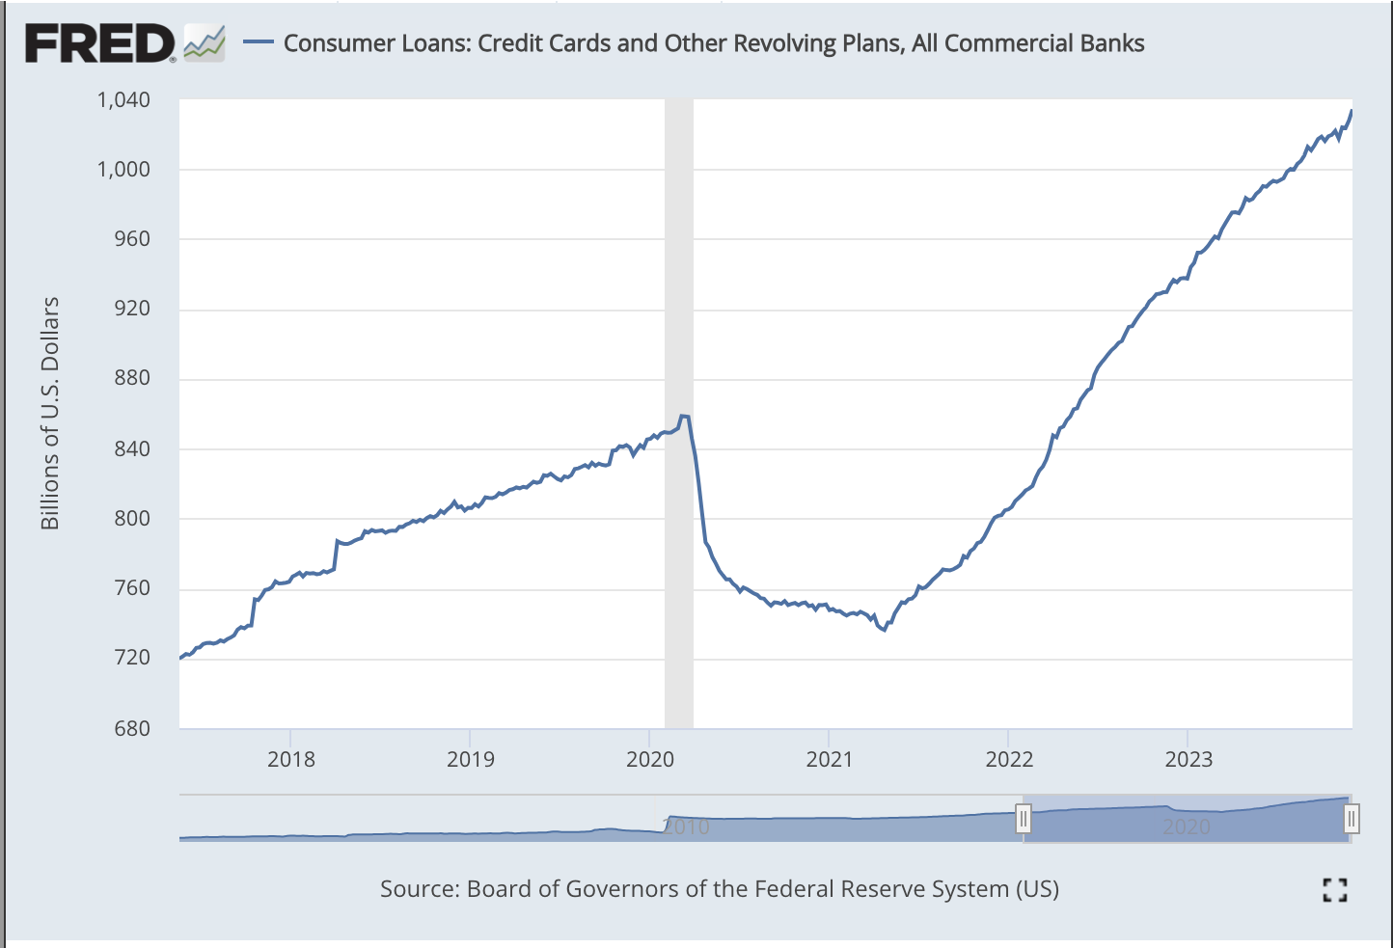
Screen 4: Bullet Template
Layout |  | Content | Designs
[Title – 45]  [Paragraph 1 – 145]  With December in flux, it can be hard to sense what market changes lie ahead  It seems like The Fed’s tactics will pay off. But where do we go from here? Here’s a few potential things to keep your eyes on:  but depending on where inflation goes, the Fed may raise or lower rates. Regardless, here’s what to watch out for:  This may have an effect on the housing market – looking to buy a home? You’ll want to pay attention to where rates are headed in 2024.  - High interest rates stick as inflation continues to dip  - A sudden change in the housing market  - Potential student loan debt relief legislation |  | [Title – / 45]  Anticipate the year to come  [Paragraph 1 – / 145]  It’s hard to tell where we’ll go from here. Wherever rates go, here are a few potential things to keep your eye on:  - Economists expect the Fed will lower rates later in 2024  - Lower rates might make for a better housing market  - Student loan debt relief legislation | 
Screen 5: List Card Template
Layout |  | Content | Designs
[Title – / 45]  [Card 1 ]  [Card title – / 30]  [Card description – / 120]  [Card 2 ]  [Card title – / 30]  [Card description – / 120]  [Card 3 ]  [Card title – / 30]  [Card description – / 120]  [Card 4 ]  [Card title – / 30]  [Card description – / 120]  No matter what, you can find control by avoiding taking on new loans and focusing payments on high interest debts, you’ll save in the long run.  Interest will likely not slow before the new year. The sooner you’re out of its way, the lower your totals will be. |  | [Title – / 45]  Every payment counts  [Paragraph – ]  No matter what, you can find control by avoiding taking on new loans and focusing payments on high interest debts. You’ll save in the long run.  [Card 1]  Card image:  $10 K  Paid at $250/month  [Card title – / 30]  Initial debt  [Card description – / 120]  Let’s say you have a credit card with a $10,000 balance, and you want to pay it down $250 each month.  [Card 2]  Card image:  $13.9 K  Over 4.6 years  [Card title – / 30]  15% rates in early-2019  [Card description – / 120]  Using the average rate from 5 years ago, it would take over 4 years to pay off the total debt + compound interest.  [Card 3]  Card image:  $25.8 K  Over 8.6 years  [Card title – / 30]  27% rates in December ‘23  [Card description – / 120]  With today’s rate, it would take an extra 4 years and over $12 K more. That more than doubles the initial amount.  [Card 4]  Card image:  2% Goal  In 2024  [Card title – / 30]  Rates won’t dip just yet  [Card description – / 120]  Interest rates likely won’t change until inflation hits 2%. The sooner you’re paid off, the lower your totals will be. | 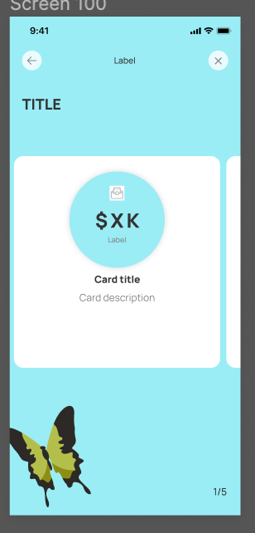
Screen 6: Full Screen Image
Layout |  | Content | Designs
[Title – 45]  [Paragraph 1 – 160] |  | [Title – 45]  Change is just on the horizon  [Paragraph – 160]  It‘s been a tough year, but you still came out on top. Focus on tackling debt and contributing to your emergency fund to be prepared for the journey ahead.
Screen 7: Takeaways
6:
Layout |  | Content | Designs
[Title – 45]  [Paragraph 1 – 147] |  | [Title – / 45]  Key takeaways  [Paragraph 1 – 147]  This year-end has plenty of frenzy, but you can still make real steps day by day. Keep an eye on the Fed, and make each payment count.  [CTA]  FAQs | 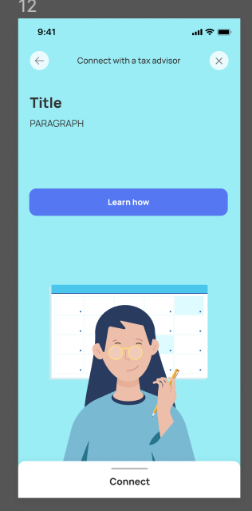
NOTES:

FAQs
# | Question | Answer
1 | I thought compounding interest was a good thing? | When it comes to debt, compounding is not your friend. It increases how much you owe and gets worse as time passes. However, it is extremely beneficial for investments, since it multiplies growth there too.
2 | What is the avalanche method? | This is another way to describe the “high-interest first” strategy. You make steady payments on debts in order of highest interest and are shielded from paying extra, even just by slowly chipping away.
3 | How else can I make progress on credit card debt? | Another way to look at credit card debt is to start at the beginning – the purchase. Consider how you can bend your spending and saving habits to fit your debt goals. For instance, building up savings or emergency funds over time can cover what would otherwise require borrowing. The shift takes time, but is worth it.
4 | I’m worried. What if I’ve borrowed too much? | Stress about debt is completely normal – owing money never feels good! Consider talking to someone about how your debt makes you feel, and know that there is always a way forward. If you act on tangible steps and expect the surprises along the way, you will make it to the other side.
5 | Can I use an investment to protect me from debt? | You want to be careful relying on them, but your investments can be a debt stormwall, especially during inflationary times. Consider moving funds to sectors that tend to match or outpace the rate of inflation, like real estate, and then leverage them to help you get out of a debt jam.

Part 3: Overview
- Feature statement
- Explore > Action Cards
- Push Notification 3

Article Feature: Key statement
[Short Description – /55]

Explore section: Action Cards
Action Card – Frame
[Header – ]
Explore more of Paven

[Subheader – ]
What’s new? What’s next? Visit your benefits or see what Paven recommends.

Action Cards
# | Label | Primary | Content | Icon
1 |  | -- credit score | [Title – / 27]  [Body – / 64]  [CTA Label – / 25]
2 |  | -- good vs bad debt | [Title – / 27 ]  [Body – / 64 ]  [CTA Label – / 25]
3 |  | -- 10 tips for credit card debt | [Title – / 27 ]  [Body – / 64 ]  [CTA Label – / 25]
Notes:

Push Notification
Authors:
Reviewers:
Overview
iOS: character limit is 178 before the text is cut off. This means four lines of text.
- Note – For iOS – Do not enter text for iOS into the Title field on Firebase – iOS doesn’t support and it breaks the layout.
Android: character limits are 65 characters for titles and 240 for descriptions.
Android
Layout |  | Message | Links to:
[Title – / 65]  [Link] |  | 2023:  Inflation cooling down?🌡️ But rates are still up 🥵 That makes paying debts tricky. Change how you take on debt and start off 2024 on the right foot 💪  What does the Fed have in store for 2024?  With rates staying up, paying debts can get tricky. Let’s map the current spike and look toward starting 2024 with ease 💪⛰️  2022:  [Title – / 65 chars]  Paying off debt?  [Description – / 240]  Rising interest can make things thornier. Let’s map the current spike and look toward starting 2023 with ease. 🌵🦋  [Link]  [insert link] | [Set and test exact path]
iOS
Layout |  | Message | Links to:
[Body – / 178]  [Link] |  | [Body – / 178]  Paying off debt? Rising interest can make things thornier. Let’s map the current spike and look toward starting 2023 with ease.   Paying off debt?  [Description – / 240]  Rising interest can make things thornier. Let’s map the current spike and look toward starting 2023 with ease. 🌵🦋  [Link]  [insert link] | [Set and test exact path]
Notes:
Hey, there’s something new in Paven for you. Update to the latest version to access.

